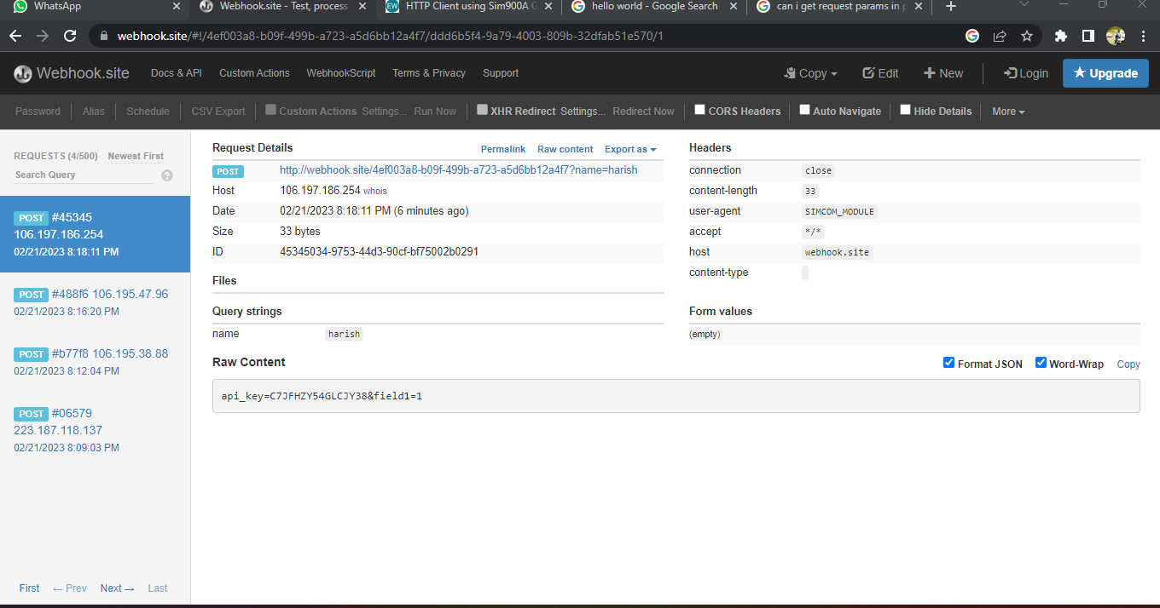

To check the request:

<https://webhook.site/#!/4ef003a8-b09f-499b-a723-a5d6bb12a4f7/ddd6b5f4-9a79-4003-809b-32dfab51e570/1>

reference:

<https://www.electronicwings.com/arduino/http-client-using-sim900a-gprs-and-arduino-uno>